CS 3240
Project Phase I

Jordan Killpack
Ka Young Kim
Byung Min
Jay Zuerndorfer

Recursive Descent Parser

Implementation Description
From a text file, it creates a stream to pass it to a parser line by line (FileToInput.Java). For each line of string passed, traverse each character, and determine the appropriate token of the character (Tokenizer.java). Each token is passed into Parser.java, which contains a grammar from the description, and records each token into a Stack (ParserToStack.java). This Stack (which holds each line – if you have more than one line, then you will have more than one Stack, which stores in ArrayList of Stack) converts into a simple Tree of String, which has a definition, such as IDENTIFIER, as a root, and all other operators (e.g. +, *, ^, (, […) as sub-roots of small Trees, Operands (e,g, DIGIT, UPPER…) will be children of sub-roots, and all Nodes are eventually children of the definition (StackToTree). The example of parsing results can be shown, if you run ParserTeser.java, on a console.

Test Case
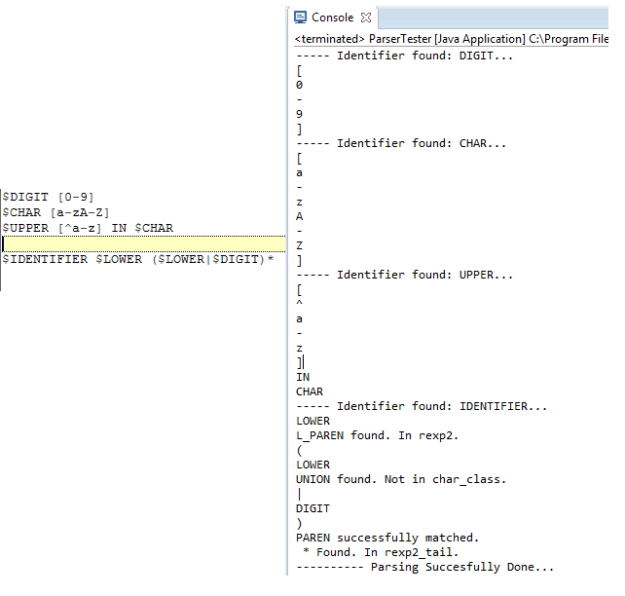
A simple test case of parser

For Parser, please run ParserTester.java with different files for more details.

NFA Simulator

Implementation Description
This runs an NFA directly. It clones the NFA each time it reaches a fork. When a clone ceases to accept input, it simply dies. The NFA scanner works by trying to get the longest possible token accepted by one of the NFAs-- it follows the rule of "maximal munch". It backtracks when necessary. It can be tested by running NFAScannerTest-- but, since we couldn't get the recursive descent parser working, it won't run directly on an input spec.

Test Case
Please refer to the test cases in the next section (NFA to DFA Conversion).

NFA to DFA Conversion

Implementation Description
The DFA constructor takes in a NFA along with its starting state and invokes build() method to construct the corresponding DFA. In build() method, the conversion is done in following manner:
- All of the allowable characters (alphabets) in the NFA are found using getAllowableCharacters() method in NFA class.
- From the starting state, its epsilon closure—the states that are reachable from the starting state—are found. Note that the method getEpsilonClosure() in DFA class is different from that in NFA class that the DFA’s version includes the starting state only if there is a transition from some state or it self-loops.
- For each state in the epsilon closure, all possible transitions on all legal characters are found using the input NFA’s transition table, which tabulates all states of the NFA and every possible transition from each of those states. After collecting the states, the states are added to the data structure that keeps track of state transitions. Then the epsilon closures of those states are found and added to the data structure.
- To convert the NFA states into corresponding DFA states, a data structure called IntermediateState is used. IntermediateState includes an attribute called “member states,” which is a set of states that holds a set of NFA states that are being combined during DFA table generation. For example, if from a starting state, state 1, state 2, and state 6, are reachable either via epsilon transition or consuming a specific character, then a new IntermediateState is created and its member states will be state 1, state 2, and state 6.
- After generating and exploring all IntermediateStates, those IntermediateStates need to be converted back into generic State. To do so, the IntermediateStates are added to an ArrayList one at a time, and another ArrayList is instantiated to store corresponding generic State. After adding all the states (possible since there are a finite number of states), an IntermediateState and its corresponding State are at the same index in their respective ArrayList.
- Lastly, the transitions among IntermediateStates are mapped to their corresponding DFA states stored in the ArrayList created in the previous step (Step 5).

Once a DFA is instantiated, doTransition() method can be used to perform transition on a certain character. To check if a string rather than a character is acceptable by the DFA, canAccept() method can be used. The method takes in an input string, consumes one character at a time, and makes transition until there is no more character to consume. If the state that the last transition returns is an accepting state, then the method returns true since the input string is acceptable by the language.

The limitation of the implementation is that it cannot convert a regular expression directly. The input regular expression or the specification of the input language must be first converted into an NFA. The DFA builder takes in the resulting NFA as an input parameter to build the corresponding DFA.

Test Case
Case 1: aa* | bb* ; ∑ = {a,b}
The first test case is a simple NFA that accepts a string made of one or more a’s or one or more b’s. The resulting DFA has 4 states. Note that (S) indicates that the state is the start state, and (*) indicates that the state is an accepting state. The results of the test case are shown below.
DFA Test Case 1
Grammar: aa* | bb*

DFA of the following NFA:
<NFA
State-0(S) {epsilon: {State-1, State-3, }}
State-1 {a: {State-2*, }}
State-2* {a: {State-2*, }}
State-3 {b: {State-4*, }}
State-4* {b: {State-4*, }}
>

State-13(*)
{ b: State-13(*); a: State-11; }
State-12(S)
{ b: State-13(*); a: State-14(*); }
State-11
{ b: State-11; a: State-11; }
State-14(*)
{ b: State-11; a: State-14(*); }

Test Strings:
Is 'aaa' legal? true
Is 'aba' legal? false
Is 'aaaaaab' legal? false

Case 2: (a|b)*a bb ; ∑ = {a,b}
The second test case tests the DFA builder for three things:
- its ability to convert union (|) correctly.
- its ability to handle Kleene star operation properly.
- its ability to interpret the NFA that is generated by concatenating several NFAs.

The resulting DFA and the results of several test cases are shown below.

DFA Test Case 2
Grammar: (a|b)*abb

DFA of the following NFA:
<NFA
State-40 {a: {State-41, }}
State-41 {epsilon: {State-46, State-44, }}
State-42 {b: {State-43, }}
State-43 {epsilon: {State-46, State-44, }}
State-44 {epsilon: {State-40, State-42, }}
State-45(S) {epsilon: {State-46, State-44, }}
State-46 {a: {State-47, }}
State-47 {epsilon: {State-48, }}
State-48 {b: {State-49, }}
State-49 {epsilon: {State-50, }}
State-50 {b: {State-51*, }}
State-51* {}
>

State-66
{ b: State-66; a: State-68; }
State-64
{ b: State-66(*); a: State-68; }
State-65(*)
{ b: State-66; a: State-68; }
State-67(S)
{ b: State-66; a: State-68; }
State-68
{ b: State-65; a: State-68; }

Test Strings:
Is 'abb' legal? true
Is 'aab' legal? false
Is 'aabb' legal? true
Is 'bb' legal? false
Is 'ababbababababb' legal? true
Is 'abababababab' legal? false

Case3: (a|b)*(ab)⁺ ; ∑ = {a,b}
The third test case is to ensure that the code is robust and to test whether the DFA builder can convert the NFA generated using Kleene plus operation.
DFA Test Case 3
Grammar: (a|b)*(ab)+

DFA of the following NFA:
<NFA
State-83 {a: {State-84, }}
State-84 {epsilon: {State-89, State-87, }}
State-85 {b: {State-86, }}
State-86 {epsilon: {State-89, State-87, }}
State-87 {epsilon: {State-85, State-83, }}
State-88(S) {epsilon: {State-89, State-87, }}
State-89 {a: {State-90, }}
State-90 {epsilon: {State-91, }}
State-91 {b: {State-92, }}
State-92 {epsilon: {State-97*, }}
State-93 {a: {State-94, }}
State-94 {epsilon: {State-95, }}
State-95 {b: {State-96*, }}
State-96* {epsilon: {State-93, }}
State-97* {epsilon: {State-93, }}
>

State-115
{ b: State-113(*); a: State-115; }
State-117
{ b: State-113(*); a: State-115; }
State-113
{ b: State-113; a: State-115; }
State-114(S)
{ b: State-113; a: State-115; }
State-116(*)
{ b: State-113; a: State-115; }
State-112(*)
{ b: State-113; a: State-115; }

Test Strings:
Is '' (empty string) legal? false
Is 'ab' legal? true
Is 'abab' legal? true
Is 'bb' legal? false
Is 'aabbaabababab' legal? true
Is 'abababbbabbba' legal? false

Note: The test results can be obtained by running NFAtoDFAtest.java

Table Walker

Implementation Description
As each character is processed, each DFA is transitioned on that character. Then the current state of the DFA is checked. If it is an accepting state, we store the current token. On the next character, if a DFA is in an accepting state it overrides the stored token with the new one so that we always have the longest valid token stored. When a space, tab, new line, or the end of file is reached the longest valid token will be returned. A backtracking buffer is filled with any characters that were read from the file but were not part of the longest valid token. When characters are being processed this buffer is emptied before reading from the file. If there is no valid token when a space, etc. is reached then the table walker throws a bad token exception.

Test Case

